**Variation in syllabification: onglides in Southwest Spanish**

**1. Introduction**

Overall, Spanish syllabification is uncontroversial. Native speakers tend to have clear intuitions about how to divide words into syllables. And yet, despite general agreement, some areas of debate have emerged in recent decades suggesting that Spanish syllabification may not be as straightforward as it is generally believed. Examples of controversial topics are the syllabification of vowel sequences as diphthongs or hiatuses and the syllabic affiliation of prevocalic glides (i.e., onglides). Some sequences of high vowel and another vowel, which are normally syllabified in one syllable as a diphthong, surface as hiatuses in some Spanish dialects. The syllabic affiliation and moraic status of vocoids (in diphthongs or hiatuses) is relevant because it has implications for the phonemic or allophonic status of glides, the nature of linguistic competence, and the mental representation of exceptional patterns (Hualde 1997, 1999, 2002). Another issue under debate involves postconsonantal glides, which have traditionally been considered part of the nucleus. Recent work, however, has challenged nuclear affiliation and argued for an onset parsing or for the possibility of both parsings.

This paper will focus on the syllabic affiliation of onglides, in particular of those in postconsonantal position, that is glides preceded by a consonant or more in the same syllable.

After a review of the literature and the arguments for onset and nuclear parsing, we argue that the debate has been oversimplified by considering either an onset or a nuclear parse. We will challenge that position by showing that, although there may be preference for a nuclear affiliation, an onset parse is also possible. We argue that an optimality theoretic model can capture and help understand the sources of variation as competing factors which result in variation in output parsing. The theoretical analysis will be supported with the results of an experimental study that show that in some Southwest Spanish varieties postconsonantal glides can go in the onset to avoid co-occurrence restrictions and limits in the number of nuclear segments.

**2. Syllabic affiliation of onglides: onset or nucleus?**

It is not surprising that glides are involved in controversial aspects of the syllabification of Spanish. Glides are opportunistic segments because of their featural composition [-consonantal, -vocalic], which makes them neither vocalic nor consonantal, and of their ability to be parsed in the margins of the syllable. It is thus their hybrid nature that makes their syllabic affiliation unclear.

In this section we provide a critical review of the affiliation arguments for postconsonantal onglides; first for a nuclear parsing, as it reflects the most common position among phonologists, followed by arguments for an onset affiliation.

The arguments in favor of the nuclear status of prevocalic postconsonantal glides have to do with co-occurrence restrictions, rhyme restrictions, diphthong/monophthong alternations, vowel harmony, hypochoristic formation, etc. (2.1-2.8 below) (cf. Hualde 2014, Shelton et al. 2012, Colina 2009).

2.1. Co-occurrence restrictions. Co-occurrence restrictions are often used as evidence that two segments cannot be part of the same subsyllabic constituent, whereas lack thereof is an indication that two contiguous segments are parsed in two separate constituents. For instance, complex onsets in Spanish have to exhibit a minimal sonority distance often described as that between an obstruent, the least sonorous of the consonants, and a liquid, the most sonorous. Therefore, a combination of a sonorant plus sonorant in an onset cluster, such as *[ml,] *[nl], *[mr], *[nr], *[nw] would be ill-formed. That sonorant- plus-glide sequences such as [mj], [nw] [rwV] [lwV] (*miedo* ‘fear’, *nueve* ‘nine’, *rueda* ‘wheel’, *liebre* ‘hare’) are possible sequences in Spanish has been used as evidence that [j] and [w] must be in the nucleus (Shelton, Gerfen and Gutiérrez-Palma 2012). This is in contrast with ill-formed *[nw], *[rwV] *[lwV] in English that are thus argued to be in the onset.

Co-occurrence restrictions can also involve point of articulation and other features such as voicing. In Spanish *[tl] is ill-formed as an onset cluster in most dialects and *[dl] in all, which is attributed to a prohibition against homorganic segments in the onset (coronal for *[tl]) and also identical voicing specification in the case of *[dl] (Harris 1983). An argument for a nuclear parsing of glides based on point-of-articulation co-occurrence restrictions rests on the well-formed status of a sequence of a bilabial stop and labial glide, such as [bw] in [bwé.no] ‘good’. Languages that parse this sequence in the onset such as English do not allow [*bw] because both segments are labial and in the onset. Consequently, the argument is that since in Spanish [bweno] is well-formed, the glide must be parsed in the nucleus (Shelton, Gerfen and Gutiérrez-Palma 2012).

Martínez-Gil (2016: 156), however, argues for the opposite position—glides are parsed as part of a complex onset—on the grounds that there exist co-occurrence restrictions in point of articulation between a palatal and a high front glide. Thus, while a palatal lateral or fricative can be followed [w] as in [ʝweβe] ‘it rains’ or [poʎwelo] ‘chick’, they are ill-formed if followed by a [j] front glide because it shares the same point of articulation [+high], *[ʝweβe] *[poʎwelo].

While it is possible to question the extent of the restrictions on palatals on the basis that they could be lexically restricted or due to historical reasons (palatal laterals in Spanish derive from complex segments, e.g. [lj], geminates, etc.), it is also reasonable to challenge Shelton et al.’s argument that glides are nuclear because a sonorant + glide onset cluster would violate sonority restrictions. While that is true, sequences in which the consonant preceding the glide is not a sonorant, such as obstruent, abide by minimal sonority distance and thus the glide could potentially be in the onset.

The number of permissible onset segments serves the basis of another argument for nuclear parsing of glides in Spanish. Many languages, including Spanish and English, limit the number of onset segments to two (unless one is /s/ in the case of English, which then permits three onset segments). Consequently, the postconsonantal glides in [trweno] ‘thunder’ and [pljeɣo] ‘fold’ in Spanish must be nuclear because an onset parse would result in a three-member cluster. However, this argument does not rule out the possibility of an onset glide when the onset has only one constituent and it is not homorganic (as in the experiment described in Section 4).

A final phonotactic argument for a nuclear parsing consists of contrasts such as *escuela* ‘school’, with an epenthetic [e] before [s], vs. *sierra* ‘mountain range’, where epenthesis is not needed (\**esierra*). Shelton et al (2012) interpret this to mean that the high glide after [s] in *sierra* must be in the nucleus, and therefore it does not have an effect on the composition of the onset. Although one cannot argue with nuclear affiliation of the glide in *sierra*, the strength of the argument for a nuclear parse of glides can be questioned because of contextual differences in the two examples. An epenthetic [e] is inserted in *escuela* to repair a decrease in sonority (from [s] to [t]) in a potential onset cluster; however, this issue is not at stake in *sierra* where sonority rises from [s] to [j]. As seen in the case of co-occurrence restrictions on onset clusters, where sonorant + glide cannot be in the onset, but an obstruent + glide could, it sometimes is the case that a restriction and its derived argument apply only to a subset of segments or to a specific context, and, therefore, cannot be used as evidence against onset glides in general.

2.2. Diphthong/monophthong alternations. Spanish has glide-plus-vowel sequences that alternate with monophthongs in unstressed morphologically related forms such as *cuello* 'neck', *collar* 'necklace'*, ciego* 'blind person', *ceguera* 'blindness'. This fact is presented as evidence for a nuclear affiliation of the glide since it is a realization of a monophthong that can be said to have a tighter connection with the nucleus than with the onset (Shelton 2012). Martínez-Gil (2016) counters this argument by pointing out that some of these alternations result in an onset glide, as demonstrated by their consonantization, as in *helar* and *hielo* [ʝelo]. However, it should be noted that, as in some of the arguments summarized above, the phonological contexts are not the same in these two sets of examples: the glide/fricative in *hielo* [ʝelo] is not postconsonantal as it is in *cuello* and *ciego* and therefore the glide could be in the nucleus in *ciego* and in the onset in [ʝelo].

2.3. Hypochoristics. Hypochoristics such as *Dani* and *Javi,* from *Dan*[je]l and *Jav[je]*r respectively, are presented as evidence for the nuclear affiliation of the glide because it appears as a full vowel in the hypochoristic (Colina 2009, Shelton, Hualde 2014, Prieto 1992), alternating thus with a full vowel. If it were in the onset, an additional vowel would be required as can be seen in examples such as \**Petr, Petro* from *Petronio*. However, Martínez-Gil (2016) contends that this cannot be considered definitive evidence for a nuclear parsing since forms like *Loli* (from *Dolores*, *Lola*) and *Pili* (from *Pilar*) indicate that [i] can form hypochoristics independently of the presence of a diphthong in the base.

2.4. Vowel harmony: Some dialects of Northwestern Spain have a high harmony process in which a stressed high vowel raises all unstressed vowels to its left, (Hualde 1991). In these varieties a prevocalic high glide behaves like a high vowel in that it triggers high harmony, as *mi lu djó* ‘he/she gave it to me’ vs. *me lo compró* ‘he/she bought it for me’ and can therefore be argued to be in the nucleus. This type of evidence is considered weak by some as it refers to a minority dialect seen distantly related to general varieties.

2.5. Children’s games: Data from children’s games has been used to support the nuclear affiliation of prevocalic glides. Hualde (2014: 199) refers to a game of *jerigonza* in which [k] is inserted after each vowel in a word and followed by a copy of the vowel, for instance, *pasa* ‘it happens’ becomes *pa-ka-sa-ka* and *están* ‘they are’ is *e-kes-ta-kan.* In this game a second member of an onset cluster is not copied, however a prevocalic glide is, as seen in *proclama* ‘it proclaims’ pro-ko-cla- ka-ma-ka vs. *puente* ‘bridge’ *pu-ku-e-ken-te-ke* or *tiene* ‘it has’ *ti-ki-e-ke-ne-ke*. However, in other varieties, which insert [p], as reported by Piñeros (1998), the prevocalic glide is omitted, *canción* ‘song’ *cam.pa.cióm.po* (61) and thus behaves like an onset consonant. Shelton et al (2012: 331) mention other types of *jerigonza* in which off glides and codas are maintained, but onsets and onset glides are not: *estoy* ‘I am’ *e-pes-to-poy*, but *también* ‘also’ *ta-pam-bie-pen* and *puerta* ‘door’ *pue-per-ta-pa* also supporting the position that prevocalic glides behave like onsets and are not nuclear. While the evidence seems contradictory, it is important to notice that it is drawn from different dialectal varieties which could exhibit differences in syllabification. This is a noticeable aspect in the literature that reviews the arguments for nuclear or onset parsings, which often does not discriminate between dialects, combining data from various dialects.

2.6. Acquisitional arguments: Studies of children with phonological delay, who simplify onset clusters to singletons, offer information regarding the syllabic affiliation of onglides. Researchers hypothesized that if CGV sequences are structurally related to CLV sequences then treatment with one group would generalize to the other. Anderson (2002) found that treatment of CGV sequences resulted in improvement of CLV sequences, suggesting that glides and liquids are syllabified in the same manner, as onsets. Other studies, however, report the opposite findings. Barlow (2005), for instance, indicates that performance on CLV sequences improved following treatment but performance on CGV sequences did not. In support of an onset parse, Kehoe et al. (2008) report that the production of rising diphthongs and branching onsets patterned similarly for the children in their study. Overall, these findings suggest variation in parsing and that at least for some children during the early stages of acquisition prevocalic glides can be part of a branching onset

2.7. Intervocalic glides. Glides in intervocalic position (when not preceded by a consonantal onset) become consonantal in most varieties of Spanish, with realizations that range from a fricative to a stop or affricate, e.g. [-jendo] *comiendo*, [ko.mjen.do] vs. *creyendo* [kre.ʝen.do]. This fact has been referred to by some (Martínez-Gil 2016) as evidence that glides are in the onset; others (Colina 2009, Hualde 2005) have taken the opposite position, contending that glide consonantization is proof that prevocalic glides are not possible onsets (unless they become consonantal) and must therefore be nuclear. The contrast in argumentation is reflective of a difference in theoretical assumptions. Martínez-Gil (2016) is framing the matter in a serial understanding of phonology in which the glide must be in the onset to become a consonant, while Hualde (2005) and Colina (2009) conceptualize the issue in a parallel framework in which consonantization is a repair mechanism to avoid an ill-formed glide in onset position. In other words, Martínez-Gil's argument presupposes a derivational account in which a glide is syllabified in the onset at some point in the derivation, and then becomes an obstruent. The glide, however, never surfaces in the onset in these dialects, weakening support for onset glides. We will return to this argument in Section 3.

Once again context is shown to have a confounding effect on the debate over the syllabic affiliation of onset glides, as the pertinent position is not intervocalic, rather postconsonantal and prevocalic: this is the position where a glide can be potentially parsed in a complex onset or a complex nucleus, as in *comiendo*, [ko.mjen.do].

2.8. Stress. Stress facts have been brought to bear on the glide debate (Núñez-Cedeño 2014). Spanish stress can fall on the last, penultimate or antepenultimate syllable. This three-syllable window for stress placement is however reduced to two when the penultimate contains a prevocalic glide or a coda, a fact that has been presented as evidence that the prevocalic glide must be part of the rhyme (i.e., nucleus) because it counts for stress purposes, \**Venézwela* *Venezwéla*. Nonetheless, in what runs counter to a nuclear parse for the prevocalic glide, the stress data also support a difference in behavior between prevocalic and postvocalic glides: a postvocalic glide in final position always attracts stress, e.g., *convóy*, ‘convoy’, while this is not the case for a prevocalic glide in the same position, *família*, ‘family’ vs. *Meliá*. The contradictory evidence derived from stress facts becomes irrelevant for the glide debate if, as Hualde (2005) does, the above generalizations are interpreted not as the consequence of a difference in parsing of the glides, but rather as a historical remnant from Latin. Spanish inherited stress in the same position it had in Latin. The unmarked antepenultimate stress of Latin became penultimate if the penultimate had a long vowel of a closed syllable, which explains the preference for the reduction of the syllable window when the penultimate has a heavy syllable. Latin also had no rising diphthongs like Spanish, which were pronounced in hiatus. This explains why forms like like *família* are possible. In sum, under the historical explanation of the stress patterns in Spanish, the stress data do not offer solid evidence for or against the nuclear parsing of glides, as the different behavior of glides with regard to stress can be attributed to a historical fact.

2.9. Experimental evidence on stress and diphthongs also supports a difference in behavior between on and off glides, that in turn are different from monophthongs. Shelton (2007), Shelton, Gerfen and Gutiérrez Palma (2010) and Shelton, Gerfen and Gutiérrez Palma (2012) found that speakers who were asked to pronounce nonce words made more errors in antepenultimately stressed syllables when the penultimate contained a falling diphthong than with a rising one, and rising diphthongs had in turn more mistakes than monophthongs (e.g. *loteiga > lotiega > lotega*). These differences can be ascribed to the position of the glide with respect to other components of the syllable, as a postconsonantal glide can move into an unoccupied onset or into a singleton onset as the second member of a cluster, whereas a postvocalic glide can only move into a nuclear position, remaining in the rhyme (cf. as proposed also by Colina and Simonet 2014, for Galician coda clusters, who argue that a nasal glide is parsed in the nucleus to avoid a complex coda clusters).

In summary, despite a predominance of phonological argumentation favoring a nuclear affiliation of postconsonantal glides, some evidence suggests that an onset parsing is also possible. We argue that the debate in the literature has been oversimplified by examining the arguments for one position or the other and trying to resolve the matter in favor of either an onset or a nuclear parse, rather than allowing for both possibilities under different conditions (cf. Shelton 2010, Hualde 2014, Martínez Gil 2016, etc.). As mentioned above, an onset parse can be an option for preconsonantal glides to avoid ill-formed configurations incurred by a nuclear parse. For instance, if the nucleus consists of a vowel followed by a glide and a coda consonant, an onset parse may help avoid having three segments in the nucleus. Similarly, dialectal variation is also possible for syllabification, and some varieties of Spanish may prefer a complex onset consisting of consonant and glide to a complex nucleus, as will be seen below. Finally, some variation may be due to lexical and postlexical distinctions. This is what Martínez-Gil (2000, 2016) proposes for syllable merger in Chicano Spanish, in whose analysis prevocalic glides and demorification of the first vocoid in a sequence is said to be the result of an onset parse postlexically.

Variation in syllabic affiliation, although not frequently considered, should not be entirely unexpected, especially in view of the non-phonemic, predictable status of syllabification in Spanish. We argue that prevocalic and postvocalic glides are opportunistic in ways not yet fully considered, in that their parsing can fluctuate depending on phonological context (such as the composition of the onset preceding it and the rhyme following, *ciego*, *jelo*), dialectal variation, and lexical and postlexical considerations, thus explaining the lack of clear-cut categorical intuition on syllabic affiliation. While Shelton et al. (2012) propose that this “inconsistent patterning of on-glides reported in the various kinds of literature... might also be best interpreted from a probabilistic perspective (341).”, other frameworks such as optimality-theory are ideally suited to account for conflicting constraints that produce different syllabic affiliation of glides.

**3. Glides in Sonoran Spanish**

In this paper we investigate an example of variation in the syllabic affiliation of postconsonantal, prevocalic glides, to determine whether the glide can be in the onset.

As mentioned above, in most varieties of Spanish, when the glide is prevocalic, but not postconsonantal (i.e., the onset is empty), the glide becomes a consonant, generally an obstruent (with various degrees of aperture/constriction, e.g., approximant, fricative, stop, affricate) and it is parsed in the onset, e.g., *-iendo* [-jen.do] ‘-ing’, *com-iendo* [ko.mjen.do] ‘eating’, vs. *creyendo* [kre.ʝen.do] ‘believing’ (Hualde 2005, Colina 2009). In other words, glides are not possible onsets. The ill-formedness of glides in the onset is one of the arguments used to support the nuclear parsing of prevocalic glides (Hualde 2005, Colina 2009). However, some Spanish varieties, such as the Spanish of Sonora, Mexico, allow glides in the onset (Canfield 1981, Alvar 1996), i.e., *creyendo* ‘believing’ [kre.jen.do], which do not consonantize. Consequently, if glides are well-formed single onsets, a glide preceded by a consonant (e.g., *i* in *tiara*) could in principle be parsed as the second element in the onset [tj] (i.e., an onset cluster), rather than in the nucleus [ja] given that it conforms to sonority restriction on onset clusters. In Section 4 we describe two experiments that set out to test this hypothesis regarding the parsing of glides in an onset cluster.

Section 2 reviewed the literature on syllabic affiliation of glides. The following paragraphs focus specifically on proposals for glide affiliation in Sonoran and more broadly on Southwest Spanish. Southwest Spanish is a variety of Spanish spoken in the southwest of the United States, in states such as Texas, Arizona, and California. Some authors also refer to it as Chicano Spanish (Martínez-Gil 2000, 2016). Southwest Spanish encompasses the variety of Sonoran Spanish spoken in border regions of Southern Arizona and in the state of Sonora, Mexico. Glides in these varieties have received significant attention in the context of across-the-word vowel merger (Hutchison 1974, Clements and Kayser 1980, Martínez-Gil 2000, 2016, Bakovic 2006, Colina 2009) and are relevant to the debate on glide affiliation, to the phonotactics of high vocoids and to dialectal variation in phonotactics.

In Southwest Spanish vowel merger, postconsonantal, prevocalic high and mid vowels surface as high glides (1a), and are deleted when they agree in backness with the following vowel (1b). A low vowel is deleted in the same context (1c). The vowel affected is always the first one in a sequence.

(1) Vowel merger in Southwest Spanish vs. Peninsular Spanish

|  |  |  |  |
| --- | --- | --- | --- |
|  | Southwest Spanish | Peninsular Spanish | Gloss |
| a. me iría | [mi.rí.a] | [mej.ría] | 'I would go' |
| b. me usó | [mju.só] | [me̯u.só] | 'S/he used me' |
| c. habla inglés | [a.βliŋ.glés] | [a.βlajŋ.glés] | 'S/he speaks English' |

Colina (2009) interprets this as a sonority-based preference for high glides (over mid) in this Spanish variety, in contrast with others like Peninsular Spanish, and for a complex nucleus rather than a complex onset. Like Bakovic (2006), Colina (2009) assumes the at-that-time standard position (and standard arguments) for the nuclear affiliation of glides (Colina 2009: 21; Colina 2010: 141-142). Martínez-Gil (2000, 2016), however, argues for an onset position, in which it is the onset parsing of the first vowel that drives the ban on mid vowels as well as the selection of the first vowel as the target for gliding and demorification. In other words, Martínez-Gil’s explanation of the dialectal differences in vowel merger is that Sonoran Spanish repairs an onsetless syllable (the one in word-initial position) through the onset parsing of the first vocoid, while other accounts claim that this is done through the creation of a complex nucleus. A robust argument in favor of Martínez-Gil’s proposal is that onset affiliation explains why it is the first vowel, not the second, that glides. Colina (2009: 59-65) points to a preference for a complex nucleus over a coda (domination of the constraint *Coda over *Complex Nucleus); yet no mention is made in the analysis of an alternative parse which violates *Complex Onset, because this possibility was ruled out through the arguments in favor of the nuclear parse.

Another piece of evidence in favor of onset parsing of glides in Sonoran Spanish presented by Martínez-Gil relates to the lexical/postlexical distinction. He states that, although arguments for lexical syllabification of postconsonantal glides favor the nucleus in many dialects, this does not affect the postlexical level. Spanish varieties that ban high glides in onset position allow them, however, when they are the result of across the word resyllabification (2). In derivational terms, in these dialects, onset glides are ill-formed lexically, but they are permitted postlexically. As Martínez-Gil (2000, 2016) indicates, vowel merger in Southwest Spanish is a postlexical process which applies across words.

(2) ley [lej] leyes [le.ʝes] ley alguna [le.jal.ɣu. na]

A final argument in support of Martínez-Gil’s analysis is that Sonoran Spanish has glides in singleton onset positions, that is, they do not consonantize as in other dialects. As discussed in Section 2, Martínez-Gil (2001) resorts to consonantization to support his view of an onset parsing for the glide, indicating that, because the glide is strengthened, it must be in the onset. The reader will recall the objection that this argument is framework dependent and that it only shows that glides are not well-formed in the onset (at least lexically), and therefore must become consonants. Nonetheless, Martínez-Gil’s (2001) consonantization argument for onset affiliation of glides turns out to be unnecessary as Sonoran Spanish does in fact allow onset glides without consonantization when they are the only segment in the onset. Whether glides are allowed as the second member of an onset cluster remains to be investigated and it is the goal of the experiment described in this paper.

**4. Experiment**

4.1 Research questions

We set out to test the hypothesis that, since onset glides are well-formed single onsets in the Spanish of Sonora, Mexico, a glide preceded by a consonant (e.g., *i* in *tiara*) could be parsed as the second element in the onset [tj] (i.e., an onset cluster), rather than in the nucleus [ja] because it conforms to sonority restrictions on onset clusters. The research questions (RQ) are thus the following:

* RQ1: Is a postconsonantal, prevocalic glide parsed as the second segment of a complex onset in Sonoran Spanish?
* RQ2: In more general terms, are Sonoran Spanish prevocalic glides always part of a complex nucleus (preceding a full vowel, in a diphthong) or can the glide be sometimes parsed in the onset?

A positive answer to either or both RQ1 and RQ2 would support the position (presented in Section 2) that the debate in the literature has been oversimplified by trying to decide in favor of either an onset or a nuclear parse for Spanish postvocalic glides, rather than considering the possibility of onset as well as nuclear parses, under different conditions.

In addition, onset parsing would suggest cross-dialectal variation in the syllabic affiliation of prevocalic glides. It is reasonable to expect that dialectal variation will affect syllabic affiliation, but little is known about cross-dialectal variation in this area of Spanish syllabification. Onset parsing of the prevocalic glide would bear out the predictions of an optimality-theoretic factorial typology in which constraint reranking predicts possible patterns of variation, such as: (i) Onset, *Onset/glide >> *Complex Nuc, Max-IOm, Ident(cons) (nuclear glide) (ii) Onset, *Complex Nuc >> *Onset/glide, Max-IOm, Ident(cons) (onset glide) (Colina 2009). We will return to this in the Discussion.

4.2 Procedure, participants and materials

Oral data were recorded in a sound isolated booth using a Shure SM10A Head mounted microphone. The participants were10 speakers of Sonoran Mexican Spanish, 18-25 years old. They were asked to perform two tasks: (i) an oral phrase reading in which the stimulus was provided in a sentence (e.g., *Digo ___ porque sí* 'I say ___ because I say so'), and (ii) an oral syllable division task. The stimuli consisted of a total of 21 nonce words (alongside 21 fillers) with a C+G+V sequence.

Two sets of stimuli were designed according to two hypotheses.

Set 1, Hypothesis 1:

Spanish only allows a maximum of three rhyme segments (Harris 1983). If a sequence of CGVGC (Consonant + Glide + Vowel + Glide + Consonant) is allowed, the glide should be in the onset, because otherwise the rhyme would contain four segments and would be illicit. According to this, a stimulus set was created that consisted of 14 four-syllable nonce words containing a postconsonantal high vocoid followed by a diphthong and a coda consonant. This could be parsed as: (i) four-segment rhyme (ill-formed) or (ii) complex onset + three segment rhyme (well-formed), e.g., *lacap*[jaj]*sto,* *lacap*[waj]*sto* (See Appendix). Four syllable words were created to avoid a glide + vowel sequence too close to the beginning or end of the word, a position known to favor hiatuses in some dialects (Hualde 1999, 2005).

Set 2, Hypothesis 2:

If the glide is in the onset, there should be onset co-occurrence restrictions, i.e., only some combinations of consonant + glide should be possible as complex clusters. Crucially, a palatal consonant + homorganic glide [j] (e.g., \**ch*[j]*aba,* *[jj]*ape,* \**ma*[ɲj]*ala)* should be disallowed because their articulations are too similar; in that case, one can argue that the glide is in the onset. On the basis of this hypothesis, 7 nonce words (not controlled for number of syllables or stress, all with the same G and V for GV, *ia*) were used as stimuli.

4.3. Statistical analyses

We report three primary statistical analyses in order to address the aforementioned research questions. To this end, we fit a series of Bayesian regression models, which are described in detail in the corresponding sections below and in the supplementary materials (<https://osf.io/fyt4d/?view_only=1e5f867b1896417cbaa21a2872221cf8>). All analyses were conducted in R (R Core Team, 2018, version 4.1.0). The models were fit using stan (Stan Development Team, 2018) via the R package brms (Bürkner, 2017). All models included a maximal grouping-effects structure (Barr, Levy, Scheepers, & Tily, 2013), as well as regularizing, weakly informative priors (Gelman, Simpson, & Betancourt, 2017). Additionally, models were fit with 2000 iterations (1000 warm-up) and Hamiltonian Monte-Carlo sampling was carried out with 4 chains distributed between 4 processing cores. We report point estimates (posterior medians) for each parameter of interest, along with the 95% highest density interval (HDI), and the maximum probability of effect (MPE). A complete description of the models and output summaries in table format are available in the supplementary materials.

4.4. Results

4.4.1. Syllable division task

The first model analyzed the syllable division task data using hierarchical multinomial logistic regression. The participants responses to the critical CGVG sequences were classified as triphthong, hiatus, or simplification, i.e., [la.ka.ˈpi̯ai̯s.to], [la.ka.pi.ˈai̯s.to], or [la.ka.ˈpai̯s.to], respectively. Given that there were three response categorizations, the model likelihood was categorical and used a logit linking function. To simplify model interpretation, we report effects in the probability space. The complete model output in the original format is available in the supplementary materials. The responses were modeled in a simple, intercept-only model, and as a function of the post-consonantal glide ([j], [w]). A “hiatus” response was set as the default and the model estimated intercepts for the “simplification” and “triphthong” responses. Figure 4.1 illustrates the overall posterior probabilities of a given response (panel A), and as a function of the glide (panels B and C).

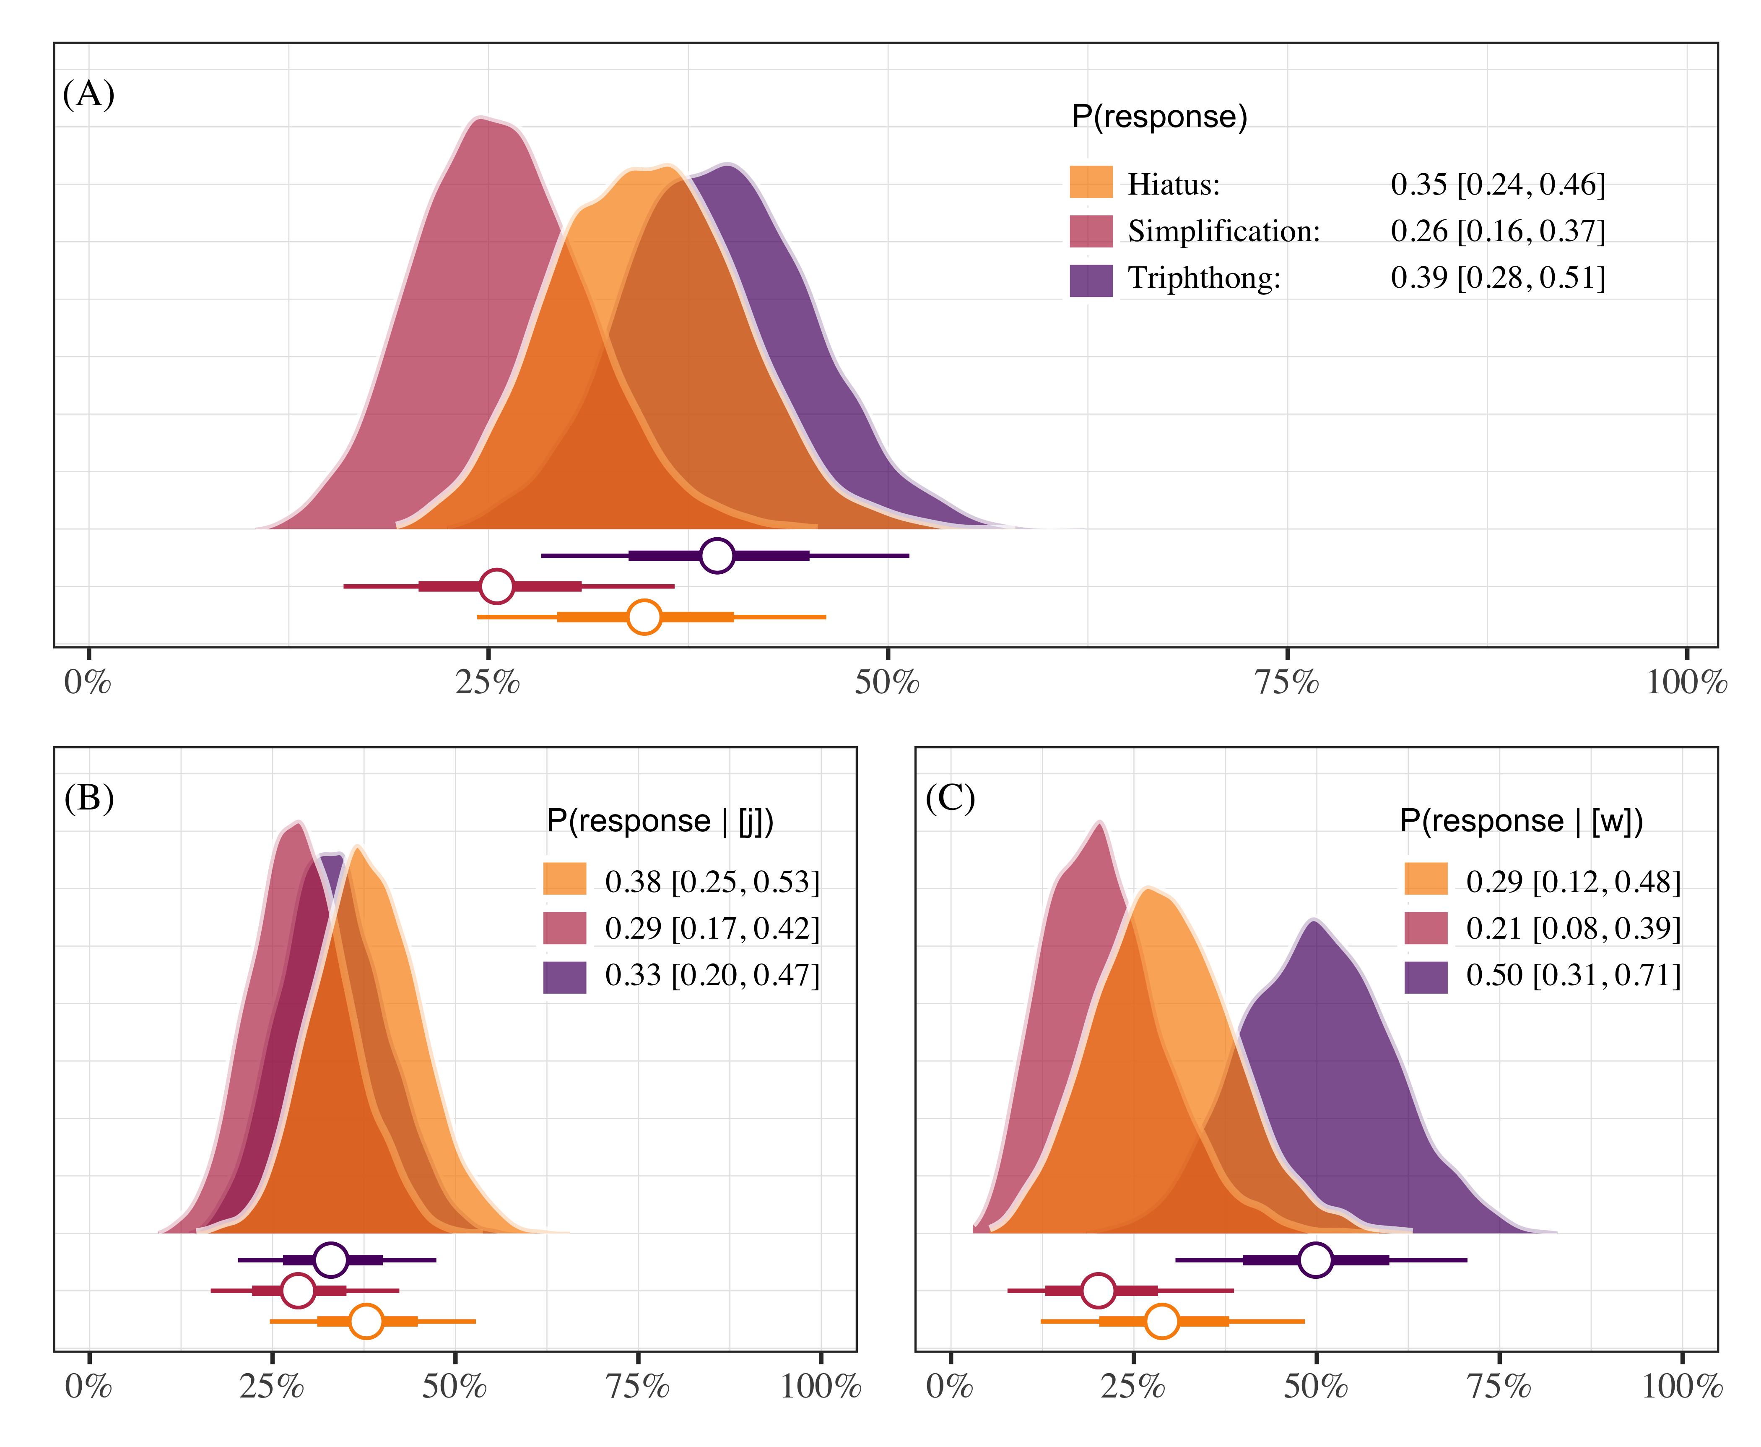

Figure 4.1: Posterior probabilities of responding “hiatus”, “triphthong”, or “simplification”. Each panel plots the posterior medians ±66% and 95% credible intervals. Panel A shows overall responses, and panels B and C show responses as a function of glide type.

With this model we aimed to shed light on how participants responded. Specifically, we were interested in knowing if GVG productions were possible and whether responses depended on the type of glide. We show that GVG responses are indeed possible. Triphthong realizations occurred approximately 39% of the time (0.39 [0.28, 0.51]) in the data set. A production containing a hiatus made up roughly 35% of the data (0.35 [0.24, 0.46]), followed by a simplification of some sort (0.26 [0.16, 0.37]). If we consider realizations as a function of glide type we see that triphthong realizations were possible in both environments, with more being produced with [w] (0.50 [0.31, 0.71]) than with [j] (0.33 [0.20, 0.47]). Overall, the task provides evidence supporting the hypothesis that pre-vocalic glides can be part of the onset in this variety of Spanish because the participants produced triphthongs at least some of the time.

4.4.2. Phrase reading task

For the phrase reading task data we fit models analyzing acoustic properties of the pre-vocalic glide [j]. Importantly, we expect co-occurrence restrictions such that pre-vocalic [j] will be disallowed if preceded by a palatal consonant. In the case that pre-vocalic [j] is indeed blocked after a palatal consonant (i.e., “lliape”), we may observe differences in overall duration of the segment, as well as formant trajectory differences related to height (F1) when compared with a pre-vocalic [j] that is not preceded by a palatal segment (i.e., “piano”). The justification for analyzing duration is due to the prediction that co-occurrence restrictions should disallow contiguous palatal consonant + homorganic glide segments, possibly resulting in an elision. Formant trajectory differences related to height (F1) are expected because in one case (i.e., “piano”) a glide should be produced without restrictions and in the other case (i.e., “lliape”) it should not. That is, in the non-palatal pre-glide items we expect formant movement from the high vocoid [j] to the low vowel [a]. If the pre-vocalic glide is blocked due to a palatal onset then we should not observe the same formant movement.

4.4.2.1. Duration

The duration data were modeled using Bayesian hierarchical linear regression. The model analyzed participant-normalized segment duration as a function of whether the onset included a palatal consonant or not—henceforth *palatal*—, which was sum-to-zero coded (1, −1, labelled as “palatal”, “other”). The model included by-participant and by-item grouping variables, and the *palatal* predictor varied for participants. The model estimates suggest that the presence of a palatal onset is associated with an increase in glide duration (β = 0.22 [−0.20, 0.62]; MPE = 0.86), though the effect is small and the credible intervals of the posterior distribution are rather wide. Concretely, based on the model, the data, and our prior assumptions, we can conclude with 95% certainty that the effect falls somewhere between −0.20 and 0.62, with an 86% chance that the effect is positive. Figure 4.2 plots the posterior distributions of pre-vocalic glides following [j] (and [w] for comparison) and Figure 4.3 provides a forest plot of the parameter estimates, including all grouping variables. A traditional table summary of the model output is available in the supplementary materials:

<https://osf.io/fyt4d/?view_only=1e5f867b1896417cbaa21a2872221cf8>.

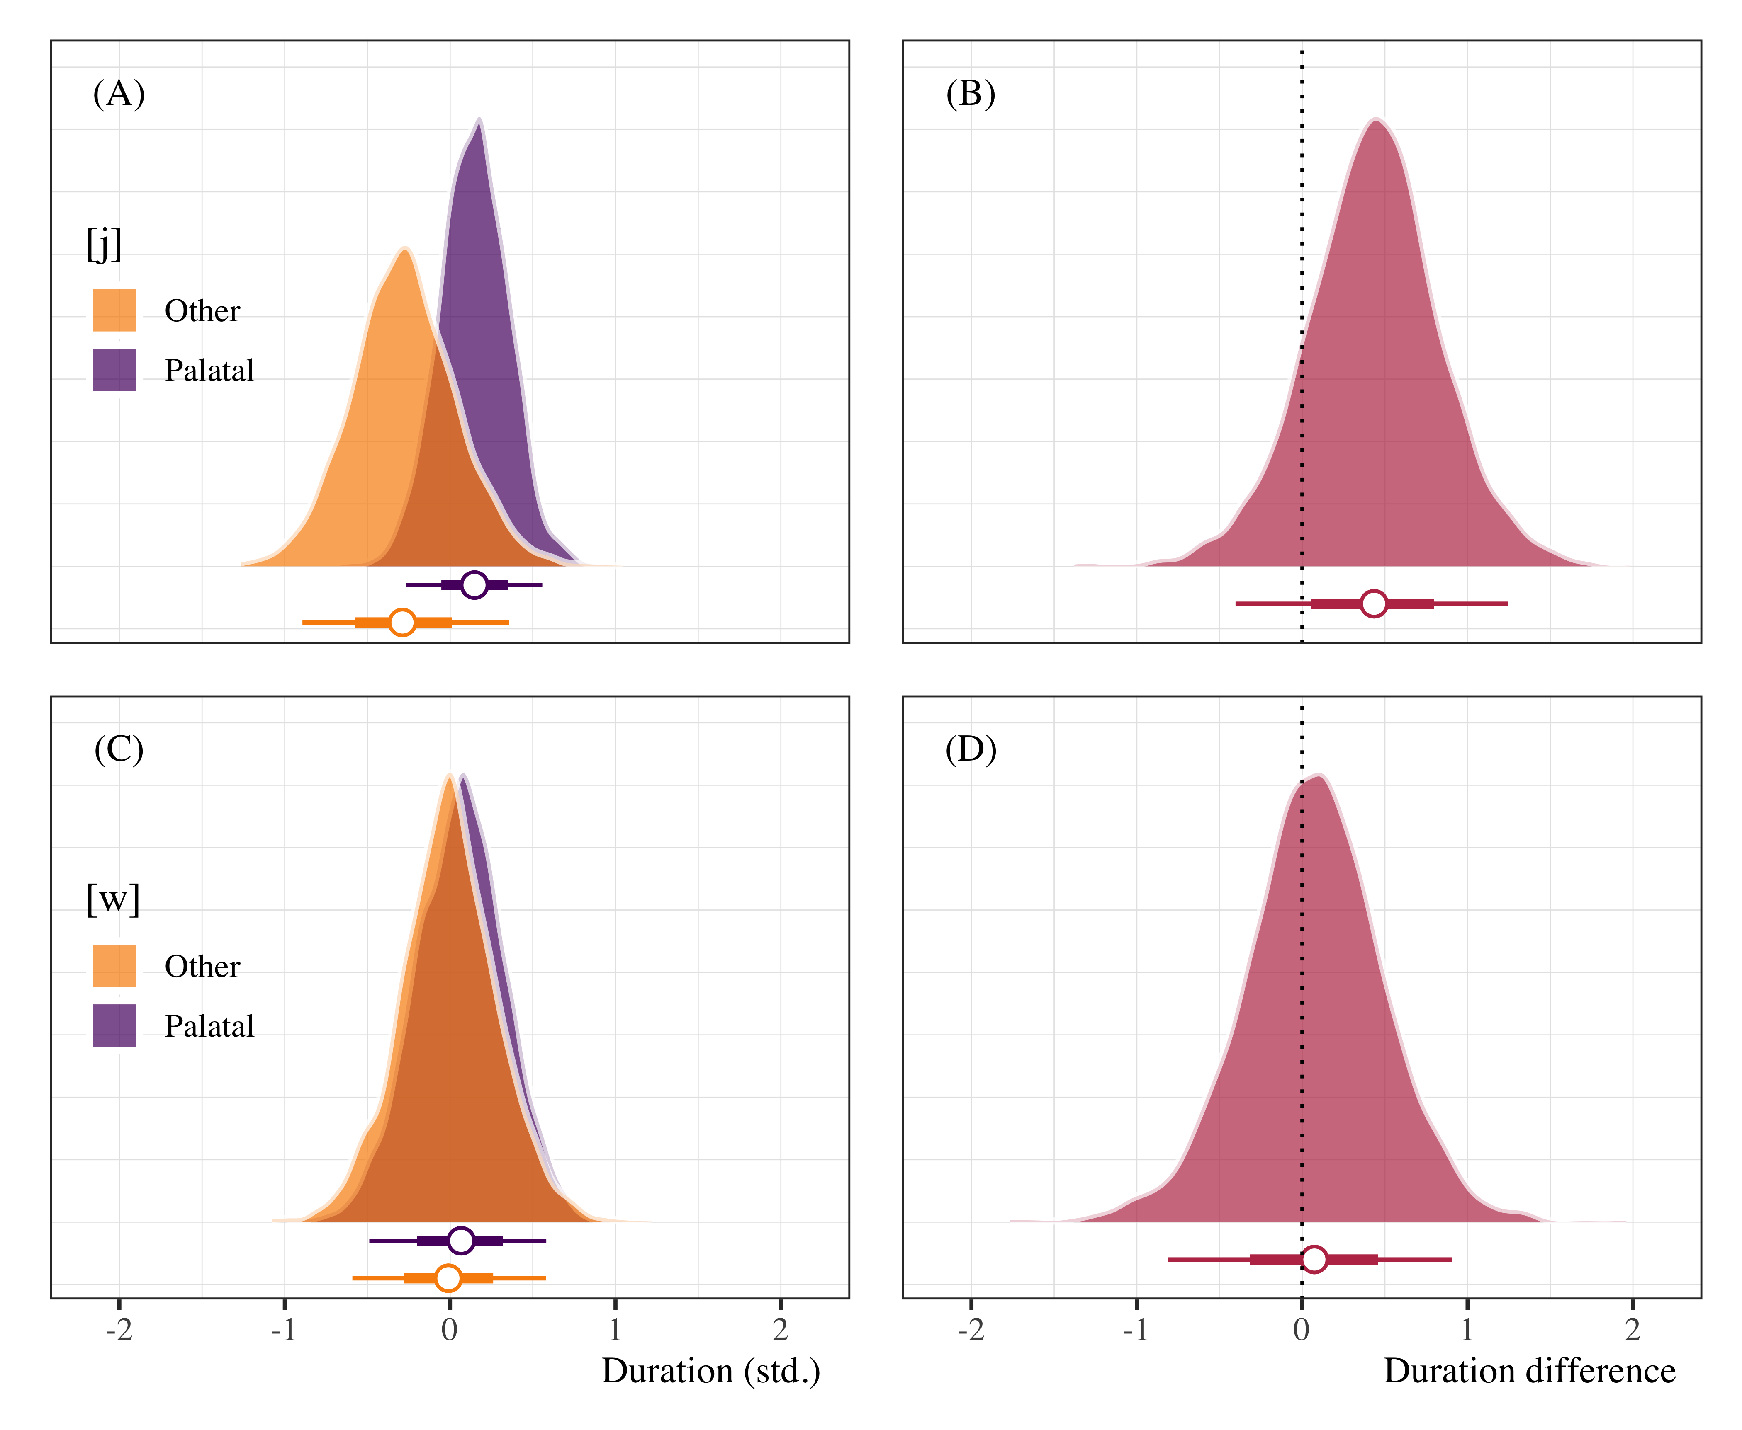

Figure 4.2: Posterior distributions of pre-vocalic glide duration (panels A and C) following palatal and non-palatal onsets, as well as duration difference plots (panels B and D). Points represent posterior medians ±66% and 95% credible intervals.

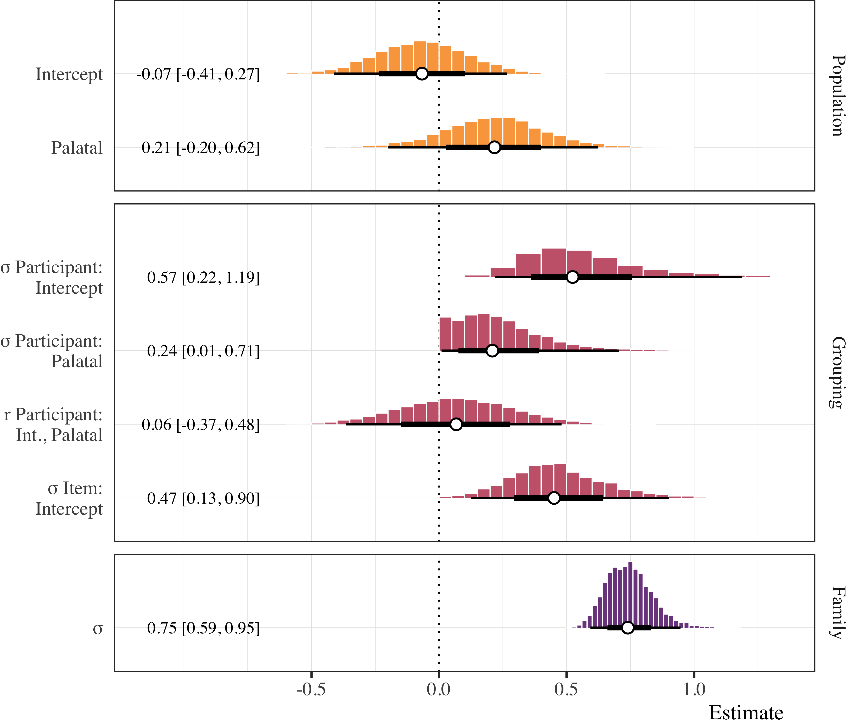

Figure 4.3: Forest plot of posterior distributions of duration model estimates. Points represent posterior medians ±66% and 95% credible intervals.

4.4.2.2. Formant trajectories

The F1 trajectory data were analyzed using a Bayesian Generalized Additive Mixed Model (GAMM, Sóskuthy, 2017; Winter & Wieling, 2016; Wood, 2006). We modeled the participant-normalized F1 values as a function of pre-glide onset, *preceding consonant* (“palatal”, “other”), and a non-linear function of the formant trajectory for the [j] productions. The *preceding consonant* parametric term was set as an ordered variable with *palatal* coded as 0. Cubic regression splines with three basis knots were applied (a) as a reference smooth to the time course, (b) as a difference smooth to the time course conditioned on the preceding consonant, and (c) as a random smooth for each participant conditioned on the time course. This specification uses the trajectory of the *palatal* condition as the baseline and compares it to the *other* trajectory.

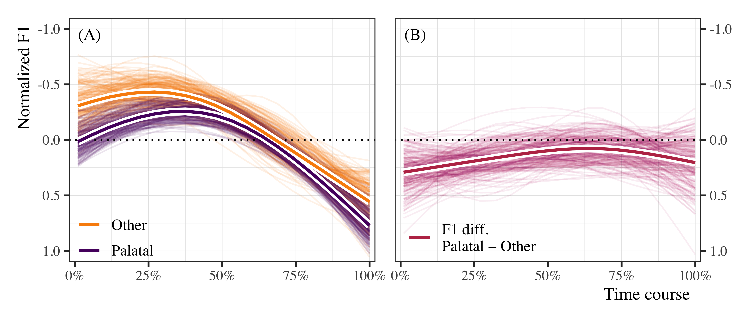

Figure 4.4: Non-linear formant (F1) trajectories of [j] when preceded by palatal and non-palatal onsets (panel A), and estimated differences (palatal − other) in standardized F1 over the time course (panel B). In both panels, the thin lines represent 300 draws of plausible lines from the posterior distribution. The thicker lines outlined in white represent the model average for the population estimate.

Panel A of Figure 4.4 plots 300 posterior draws of plausible lines for the time course of the F1 trajectories in the palatal and other conditions. The thicker lines outlined in white represents the most plausible trajectories based on the data, the model, and our prior assumptions. One observes non-linear trajectories that are generally non-overlapping at the beginning of the time course and tend to converge on a single trajectory after approximately 50% of the time course. The estimates for the difference smooth suggest a small, negative effect with a moderate amount of uncertainty around the estimate (β = −0.15 [−0.31, 0.00]; MPE = 0.98). The probability that the effect is negative is approximately .98. The uncertainty around the estimate is manifested in panels A and B of Figure 4.4 by the overlapping colored lines. Panel B plots the estimated difference between the palatal and other conditions. The figure corroborates the estimates from the GAMM, as there appears to be a non-zero difference between trajectories during the first half of the time course, though some plausible estimates indicate that the difference may also be zero. Figure 4.5 provides a forest plot of the model summary. A traditional table summary is provided in the supplementary materials:

<https://osf.io/fyt4d/?view_only=1e5f867b1896417cbaa21a2872221cf8>.

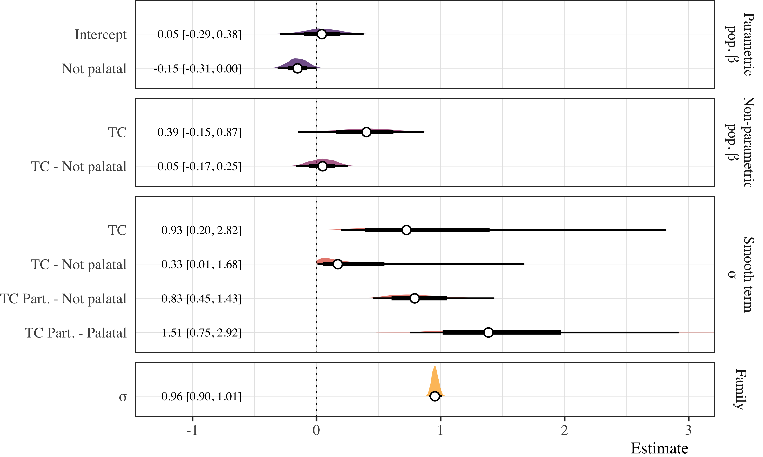

Figure 4.5: Forest plot of posterior distributions from the GAMM analyses of the F1 time course for [j]. Points represent posterior medians ±66% and 95% credible intervals for which numeric summaries are provided in the left margin. Vertical faceting distinguishes between parametric (top) and non-parametric population estimates, followed by grouping estimates for smooth terms and overall standard deviation.

**5. Discussion**

5.1. Summary of findings

The results of the production experiments suggest that Sonoran speakers used variable strategies when producing the CGVGC sequences. Importantly, they produced the GVG sequence at least some of the time in the syllabification task, indicating that this realization is indeed possible, though not categorical. An acoustic analysis of the production data from the phrase reading task indicates that pre-vocalic [j] may be realized with subtle differences after palatal consonants. Taken together, the duration and formant trajectory analyses suggest (1) that participants may be producing slightly *longer* pre-vocalic [j] when preceded by a +palatal onset segment, and (2) that the starting point for the F1 transition from [j] to [a] is slightly lower when the onset contains a +palatal segment. Concretely, [j] was not shortened or elided as hypothesized due to co-occurrence restrictions. On the contrary, we find evidence that the hypothesized co-occurrence restriction may result in lengthening of the onset segment. One possibility is that the participants may be producing a slightly longer segment, as opposed to eliding it, in the palatal condition because of the fact that they cannot naturally produce both. That is, our exploratory analysis of the [j] time course suggests that the tendency to increase duration could be a strategy to avoid the illicit sequence.

* Acoustic analysis shows that pre-vocalic segments are longer after palatal consonants, revealing a strategy to avoid an illicit sequence. In the syllabification task, speakers produce triphthongs in 45% of the targets, so onset parsing is possible, but not categorical.
* As predicted, onset parsing suggests cross-dialectal variation in the syllabic affiliation of prevocalic glides. Furthermore, the parsing of glides also exhibits dialect-internal variation, as some, but not all glides are in parsed the onset.
* The rankings predicted by an optimality-theoretic factorial typology are variable/non-categorical: (i) Onset, *Onset/glide >> *Complex Nuc, Max-IO𝝻, Ident(cons) (nuclear glide) (ii) Onset, *Complex Nuc >> *Onset/glide, Max-IO𝝻, Ident(cons) (onset glide) (Colina 2009).
* The variable, non-categorical rankings above (underlined) can be modelled in stochastic OT (Boersma and Hayes 2001 )
* Further research is needed to study the factors conditioning the variation (they do not appear to be phonological)
* This study could be replicated with more subjects (controlled for sex, age, linguistic profile), and, for comparative purposes, also with speakers of dialects that do not allow onset glides.

6. Conclusion

* In this study we examined the syllabic affiliation of prevocalic glides in Sonoran Spanish
* Since glides are licit in the onset (i.e., no onset strengthening in Sonoran Spanish), a postconsonantal, prevocalic glide could be parsed as the second segment of a complex onset in Sonoran Spanish.
* Experimental evidence showed that Sonoran speakers produced the GVG sequence at least some of the time (thus it is possible). Acoustic analysis shows that pre-vocalic segments are longer after palatal consonants; the duration increase is shown to be due to lengthening of onset (a strategy to avoid illicit sequence).
* Glides can be variably parsed as C2 in a complex onset. Onset glides in Sonoran Spanish provide evidence for cross-dialectal and intra-dialectal variation in syllabic affiliation.

**References**

Barlow, J. (2005) “Phonological Change and the Representation of Consonant Clusters in Spanish: A Case Study,” Clinical Linguistics and Phonetics 19, 659–679.

Barr, D. J., Levy, R., Scheepers, C., & Tily, H. J. (2013). Random effects structure for confirmatory hypothesis testing: Keep it maximal. *Journal of Memory and Language*, *68*(3), 255–278.

Bürkner, P.-C. (2017). brms: An R package for Bayesian multilevel models using Stan. *Journal of Statistical Software*, *80*(1), 1–28. <https://doi.org/10.18637/jss.v080.i01>

Colina, S. 2012. Syllable Structure. The Handbook of Spanish Linguistics.

Colina, Sonia & Miquel Simonet. 2014. “Galician Coda Restrictions and Plural Clusters.” *Linguistics* 52 (6): pp. 1433-1460.

Gelman, A., Simpson, D., & Betancourt, M. (2017). The prior can often only be understood in the context of the likelihood. *Entropy*, *19*(10), 1–13. <https://doi.org/10.3390/e19100555>

Hualde, José I. 1997. “Spanish /i/ and related sounds: an exercise in phonemic analysis.” *Studies in the Linguistic Sciences* 27: 61-79.

Hualde, José I. 1999a. “Patterns in the lexicon: hiatus with high unstressed high vowels in Spanish.” In Javier Gutiérrez-Rexach y Fernando Martínez-Gil, eds. *Advances in Hispanic linguistics. Papers from the 2nd Hispanic Linguistics Symposium*. Somerville, MA: Cascadilla. 182-197.

Hualde, José I. 2002. “On the diphthong/hiatus contrast in Spanish: some experimental results.” *Linguistics* 40: 217-234.

Michael Shelton, Chip Gerfen & Nicolás Gutiérrez Palma (2012) The interaction of subsyllabic encoding and stress assignment: A new examination of an old problem in Spanish, Language and Cognitive Processes, 27:10, 1459-1478, DOI: [10.1080/01690965.2011.610595](https://doi.org/10.1080/01690965.2011.610595)

R Core Team. (2018). *R: A language and environment for statistical computing*. Vienna, Austria: R Foundation for Statistical Computing. Retrieved from <https://www.R-project.org/>

Sóskuthy, M. (2017). Generalised additive mixed models for dynamic analysis in linguistics: A practical introduction. *arXiv Preprint arXiv:1703.05339*.

Stan Development Team. (2018). Stan modeling language users guide and reference manual (Version 2.18.0). Stan Development Team. Retrieved from <http://mc-stan.org>

Winter, B., & Wieling, M. (2016). How to analyze linguistic change using mixed models, growth curve analysis and generalized additive modeling. *Journal of Language Evolution*, (1, 1), 7–18.

Wood, S. (2006). *Generalized additive models: An introduction with r* (2nd ed.). Boca Raton: CRC Press.